

**Faculty of Engineering & Technology Electrical and Computer Engineering Department**

**Communications Laboratory Report #1:**

**Experiment No 2. DSB-SC and SSB-SC Modulation and Demodulation**

|  |  |
| --- | --- |
| **Prepared by:** |  |
| Arwa Doha | 1190324 |
| **Partners:** |  |
| Hamza Awashra | 1201619 |
| Saleh Zhour | 1201941 |

**Instructor:** Dr.Ashraf Al-Rimawi **Assistant:** Mohammad Al-Battat **Section:** 6

# Date: November 29, 2023

**Abstract**

The aim of this experiment is to understand the amplitude modulation specifically in DSB-SC and SSB-SC and to understand the difference between them. Moreover, we show the modulation and demodulation of various signals in both the frequency domain and time domain and discuss the results in comparison with the theoretical part and math calculations. Also, we discuss the importance of filters and how they affect signals.

# Table of Contents

### Abstract I

1. [**Theory**](https://docs.google.com/document/d/1bJtlnOT_Cf2HDBLa6Q0fTgGsQyMr-ABqseQClZ0zYYQ/edit#heading%3Dh.dmshv0kvip70)
   * 2.1 Double SideBand Suppressed-Carrier Modulation 1
   * 2.2 Double SideBand Suppressed-Carrier Demodulation 3
   * 2.3 Single SideBand-Suppressed Carrier Modulation 4
   * 2.4 Single SideBand-Suppressed Carrier Demodulation 5
2. [Procedure and D](https://docs.google.com/document/d/1bJtlnOT_Cf2HDBLa6Q0fTgGsQyMr-ABqseQClZ0zYYQ/edit#heading%3Dh.i5b9td577uci)ata Analysis
   * 3.1 Double-side band suppressed carrier amplitude Modulation: 6
   * 3.2 Double-side band suppressed carrier Demodulation: 15
   * 3.3 Single-sideband Suppressed carrier Modulation 19
   * 3.4 Single-sideband Suppressed carrier Demodulation 26

[Conclusion](https://docs.google.com/document/d/1bJtlnOT_Cf2HDBLa6Q0fTgGsQyMr-ABqseQClZ0zYYQ/edit#heading%3Dh.2ajmbri2k2qt) 32

[References](https://docs.google.com/document/d/1bJtlnOT_Cf2HDBLa6Q0fTgGsQyMr-ABqseQClZ0zYYQ/edit#heading%3Dh.rb1nryd0zcyc) 33

**Table of Figures**

* Figure 1: DSB-SC Waveform 1
* Figure 2: Generation of DSB-SC signal 2
* Figure 3: Coherent Detector with DSB-SC 3
* Figure 4: Coherent Detector whith SSB-SC 5
* Figure 5: DSB-SC Modulation 6
* Figure 6: Time-domain plot of m(t) and s(t) 7
* Figure 7: Frequency-domain plot of m(t) and s(t) 7
* Figure 8: Modulated and message signal at fm=1khz (Time domain) 8
* Figure 9: Modulated and message signal at fm=1khz (freq Domain) 8
* Figure 10: Modulated and message signal at fm=3khz (Time domain) 9
* Figure 11: Modulated and message signal at fm=3khz (Freq domain) 9 s
* Figure 12: Modulated and message signal at Vss=2v (Time.domain) 10
* Figure 13: Modulated and message signal at Vss=2v(Freq.Domain) 11
* Figure 14: Modulated and message signal at Vss=6v (Time.domain) 11
* Figure 15: Modulated and message signal at Vss=6v (Freq.Domain) 12
* Figure 16: Modulated and message signal at Vss=4v (with-LPF) 13
* Figure 17: Modulated and message signal at Vss=4v (with-LPF) 13
* Figure 18: Modulated and message signal at fm=3khz (without-LPF) 14
* Figure 19: Modulated and message signal at fm=3khz (without.LPF in Freq.Domain) 14
* Figure 20: Demodulation setup 15
* Figure 21: Demodulation without (output filter) 15
* Figure 22: Demodulation (without output filter) 16
* Figure 23: Demodulation (with output filter) 16
* Figure 24: Demodulation (with output filter in Freq.Domain) 17
* Figure 25: output message signal disappears 18
* Figure 26: SSB-SC Modulation setup 19
* Figure 27: SSB-SC modulation 19
* Figure 28: SSB-SC modulation(Freq.Domain) 20
* Figure 29: SSB-SC modulation Fm= 1khz 21
* Figure 30: SSB-SC modulation Fm= 1khz(Freq.Domian) 21
* Figure 31: SSB-S modulation Fm= 3khz (Time.domain) 22
* Figure 32: SSB-SC modulation Fm= 3khz(Freq.Domian) 22
* Figure 33: SSB-SC modulation Vss to 2V(Time.domain) 23
* Figure 34: SSB-SC modulation Vss to 2V(Freq.Domian) 24
* Figure 35: SSB-SC modulation Vss to 6V(Time.domain) 24
* Figure 36: SSB-SC modulation Vss to 6V(Freq.Domian) 25
* Figure 37: SSB-SC Coherent Demodulation Setup 26
* Figure 38: SSB-SC Coherent Demodulation with output filter(Time.domain) 26
* Figure 39: SSB-SC Coherent Demodulation with output filter (Freq.Domain) 27
* Figure 40: SSB-SC Coherent Demodulation without output filter(Time.domain) 27
* Figure 41: SSB-SC Coherent Demodulation without output filter(Freq.Domain) 28
* Figure 42: SSB-SC Non-Coherent Demodulation(Time.domain) 29
* Figure 43: SSB-SC Non-Coherent Demodulation(Freq.Domain) 29
* Figure 44: PPL demodulation setup 30
* Figure 45: PPL demodulation(Time.domain) 30
* Figure 46: PPL demodulation (Freq.Domain) 31

# Theory

## Double SideBand Suppressed-Carrier Modulation

When transmitting a message signal over long distances, modulation becomes crucial. In this experiment, the chosen modulation method is Double SideBand Suppressed-Carrier, a type of amplitude modulation. Amplitude modulation showcases the alterations in the carrier's amplitude corresponding to changes in the message signal's amplitude. This modulation generates two sidebands: the lower sideband (LSB) with frequencies lower than the carrier and the upper/sideband (USB) with frequencies higher than the carrier.[1].

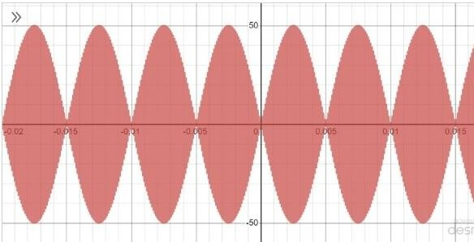

Figure 1: DSB-SC Waveform [1]

In Double SideBand Suppressed-Carrier (DSB-SC) modulation, the process involves multiplying the message signal by the carrier signal to create the modulated signal. After this multiplication, applying the Fourier Transform helps represent this modulated signal in the frequency domain, allowing us to analyze its frequency components and characteristics.

m(t) = Am.cos(2pi.fm.t)

c(t) = Ac.cos(2pi.fc.t)

s(t) = m(t)*c(t) = ( (Am.*Ac) / 2).[ cos(2.pi.( fc+fm ) ) + cos(2.pi( fc-fm ))]

S(f) = (Am*Ac / 2)[( δ - ( fc+fm )) + ( δ + (fc+fm) ) + ( δ - (fc-fm) ) + ( δ + (fc-fm) )]

Plotting the spectrum in the frequency domain based on the provided equations allows us to determine the bandwidth by subtracting the higher-frequency (USB) from the lower-frequency (LSB), resulting in (fc+fm) - (fc-fm) = 2fm. This calculation signifies that the bandwidth of the DSB-SC modulation is twice the message signal frequency (2fm). A notable advantage of DSB- SC modulation is its 100% efficiency, attributed to the suppression of the carrier, leading to significantly lower power consumption.[2].

Efficiency in percentage (%) = ( Power-Of-Sides / Total-Power ) * 100% Power in Time Domain = ( Am.*Ac ) / 2 ) ^2

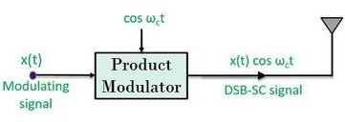

Figure 2: Generation of DSB-SC signal [2]

## Double SideBand Suppressed-Carrier Demodulation

In DSB-SC demodulation, retrieving the original message signal on the receiver's end requires a specific technique. Here, the modulated signal is multiplied by another carrier signal, and the outcome is directed through a low pass filter to permit only the low-frequency components, representing the message signal. The carrier signal utilized for this process can vary: it might carry a specific phase (Non-coherent demodulation) or have a phase of zero (

Coherent Demodulation). Following the multiplication of the modulated signal with the new carrier, two terms emerge, the-first term is directly proportional to the message signal = (( Ac.*Ac' ) / 2 ).*cos( ϕ.m(t) ) and the second term = (( Ac.*Ac') / 2 ).cos( 4π.fc.t + ϕ ).m(t). After applying this to a low pass filter only the first term is passed since the second term has a high frequency[3].

v(t) = s(t).* c'(t)

c'(t) = Ac'.cos.( 2π.fc.t + ϕ )

⇒ v(t) =Ac.*cos( 2π.fc.t )*m(t)*Ac'.cos( 2π.fc.t + ϕ )

= ( Ac.*Ac')*cos( 2π*fc*t). cos( 2π*fc*t + ϕ )*m(t)

= ((Ac.*Ac') / 2 )*[ cos(4π*fc*t + ϕ ) + cos(ϕ) ]*m(t)

v(t) = ((Ac.*Ac') / 2 )*cos( ϕ*m(t) + (Ac*Ac') / 2 )*cos(4π*fc*t + ϕ ) * m(t)

➔ After Low Pass Filter: v(t)= (( Ac.*Ac' ) / 2 ) * cos( ϕ*m(t) )

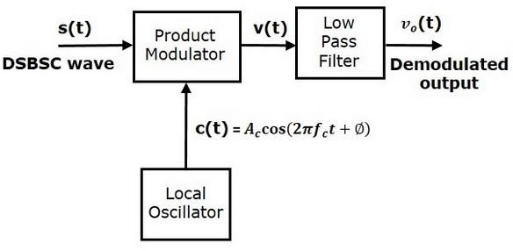

Figure 3: Coherent Detector with DSB-SC [3]

## Single SideBand-Suppressed Carrier Modulation

In the Double SideBand Suppressed Carrier (DSB-SC) modulation, both sidebands carry identical information. However, transmitting both sidebands isn't necessary. By selecting only one of the sidebands, it transforms into a Single SideBand Suppressed Carrier (SSB-SC). To generate SSB-SC, the output of DSB-SC is directed through a bandpass filter, allowing either the upper-or lower sideband to pass. As DSB-SC's bandwidth is = 2*fm, selecting only one sideband for SSB-SC reduces its bandwidth to half, resulting in a bandwidth of 2fm / 2 = fm.

This represents a more efficient utilization of the available frequency spectrum.

m(t) = Am*cos( 2π*fm*t) c(t) = Ac*cos( 2π*fc*t )

s(t) = (( Am*Ac ) / 2 ) * cos[ 2π (fc + fm).t ]. → for the upper sideband s(t) = ((Am*Ac ) / 2 ) * cos[ 2π (fc − fm).t]. → for the lower sideband Power in Time Domain: (( Am*Ac ) / 2 ) ^2 ) / 2

## Single SideBand-Suppressed Carrier Demodulation

In extracting the message signal from the Single SideBand Suppressed Carrier (SSB-SC) modulated signal, the process involves multiplying the chosen modulated signal (either upper or lower sideband) by a new carrier signal. This multiplication results in a combined signal.

Passing this combined signal through a low pass filter allows only the low-frequency component—the message signal—to pass through, separating and retrieving the original message signal.[4].

v(t) = s(t).* c(t)

v(t) = (( Am.Ac ) / 2 ) * cos[ 2π.(fc−fm).t] *Ac'.cos( 2π*fc*t)

= ((Am*Ac*Ac') / 2 )* cos[ 2π.(fc−fm)*t] *cos( 2π.fc.t)

= (( Am*Ac*Ac') / 4 ) * { cos [ 2π.(2fc−fm) ] + cos (2π*fm)*t }

The output of*the low pass filter: v(t) = (( Am*Ac*Ac' ) / 4 )* cos ( 2π*fm*t )

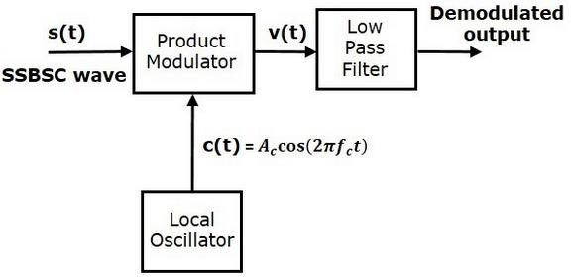

Figure 4: Coherent Detector whith SSB-SC[4]

# Procedure and Data Analysis

## Double-side band suppressed carrier amplitude Modulation:

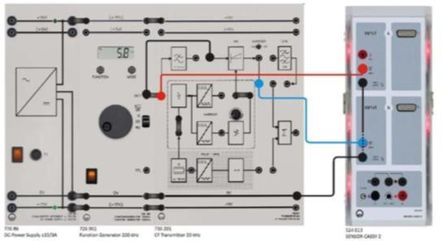

Figure 5: DSB-SC Modulation [5]

To begin the DSB-SC modulation process, we followed the instructions provided in the accompanying figure and connected the components accordingly. The modulated signal, denoted as s(t) and calculated as the product of the message signal (m(t)) and the carrier signal (c(t)):

s(t) = m(t)*c(t), required us to deactivate the Carrier toggle switch. This switch is typically active during Normal amplitude modulation. By setting VSS to 4V and fm to 2 kHz, we were able to generate the message signal and modulated signal. We then proceeded to plot these signals for further analysis..

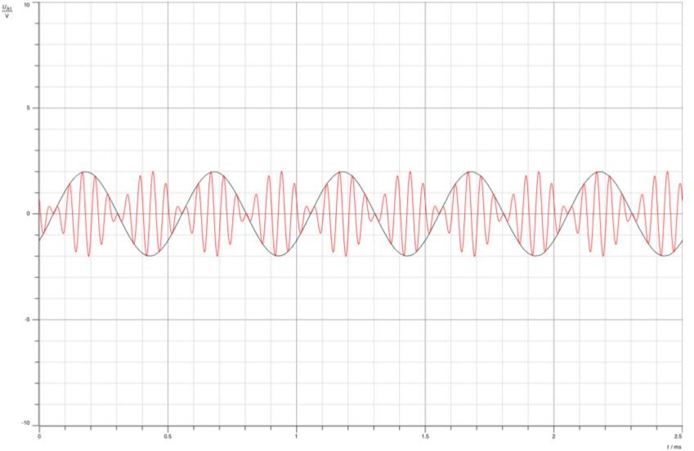

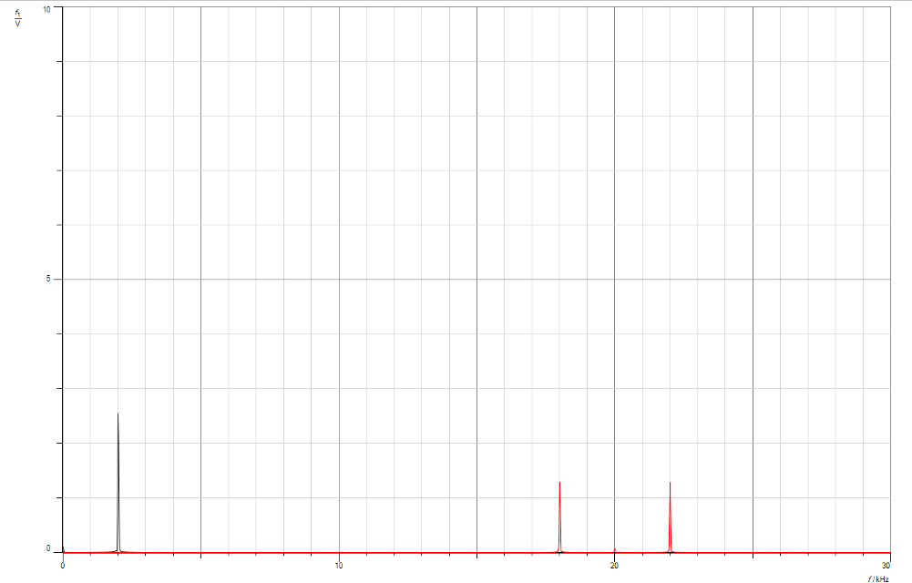Figure 6: Time-domain plot of m(t) and s(t)

Figure 7: Frequency-domain plot of m(t) and s(t)

The message signal, denoted as m(t), is given by the equation m(t)=2cos(2π2k*t), while the carrier signal, c(t), is represented by Accos(2πfc*t). The modulated signal, s(t), can be obtained by multiplying the message signal and the carrier signal together: s(t) = m(t) * c(t) = 2cos(2π2k*t) * Accos(2πfc*t) = 2 * Ac/2 [cos(2π(f20k+2k)) + cos(2π(20k-2k))]. By observing the figure provided, we can determine that fc is equal to 20kHz because the two sidebands are located at 22kHz (fc + fm) and 18kHz (fc - fm). In the frequency domain, it is evident that the

carrier signal is suppressed since this is a DSB-SC modulation. Now, in order to proceed with the next step, we will adjust the frequency (fm) to 1kHz and 3kHz (using a low pass filter) while keeping Vss at 4V.

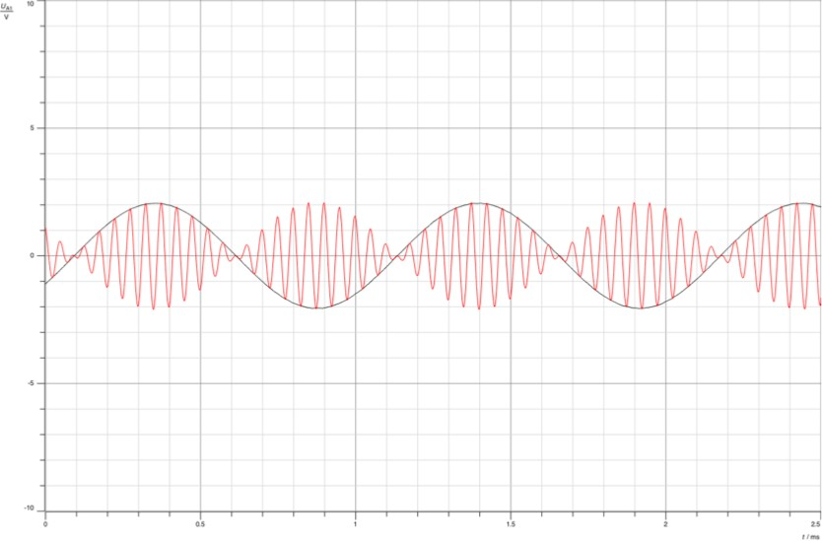

Figure 8: Modulated and message signal at fm=1khz (Time domain)

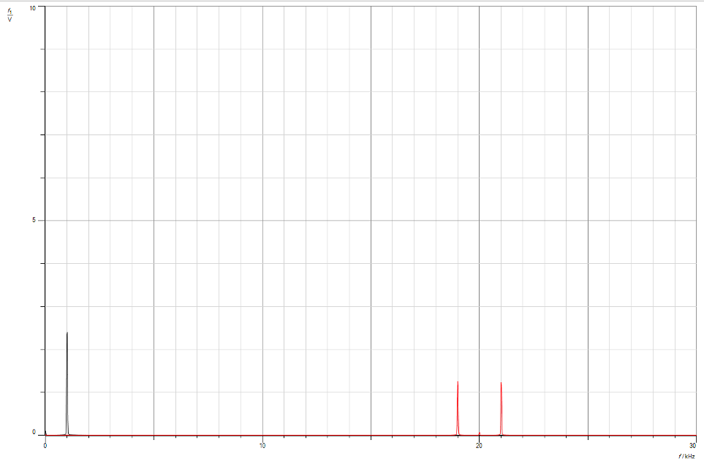

Figure 9: Modulated and message signal at fm=1khz (freq Domain)

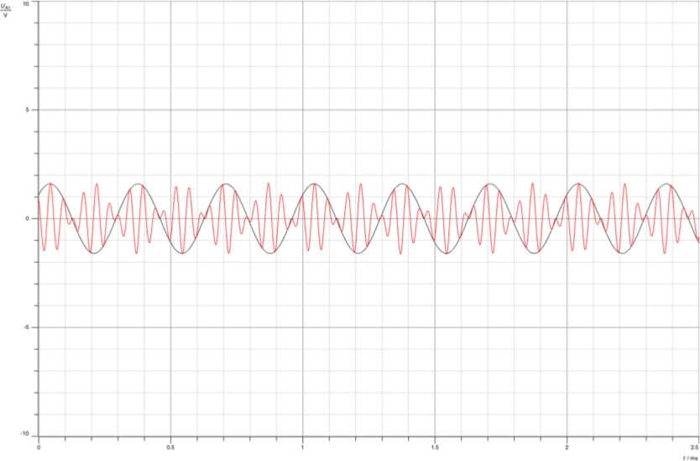

Figure 10: Modulated and message signal at fm=3khz (Time domain)

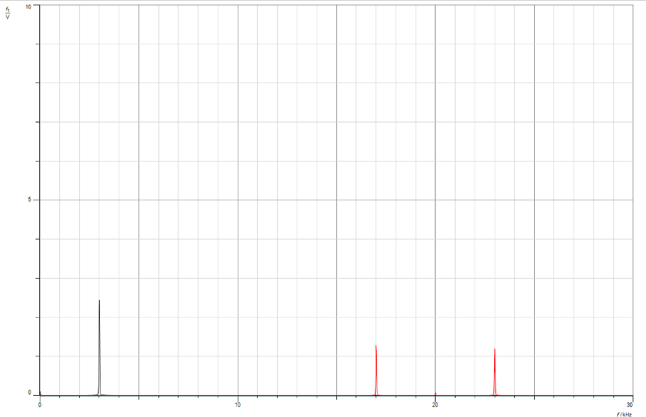

Figure 11: Modulated and message signal at fm=3khz (Freq domain)

From analyzing the provided figures, we have observed that altering the frequency of the modulating signal leads to a corresponding change in the frequency of the modulated signal, specifically the two sidebands. For instance, when the modulating frequency (fm) was set to 1kHz, the sidebands occurred at 19kHz and 21kHz. Similarly, when fm was adjusted to 3kHz, the sidebands appeared at 17kHz and 23kHz. It is important to note that the transmission bandwidth varies in relation to the modulating frequency, with a bandwidth equal to 2 times the value of fm. Therefore, in the first scenario with fm=1kHz, the bandwidth amounted to 2kHz, while in the second case with fm=3kHz, the bandwidth increased to 6kHz. Moving forward, we will explore the impact of varying the amplitude of the message signal while keeping fm constant at 2kHz. Specifically, we will examine the effects of adjusting the message voltage (Vss) to 2V and 6V. To calculate the power at the sidebands, we square the amplitude of the sidebands, which is approximately 1.19 in this case. Consequently, the power for each sideband is approximately 1.416, resulting in a total power of 2.83. It is important to highlight that the efficiency observed here is 100%

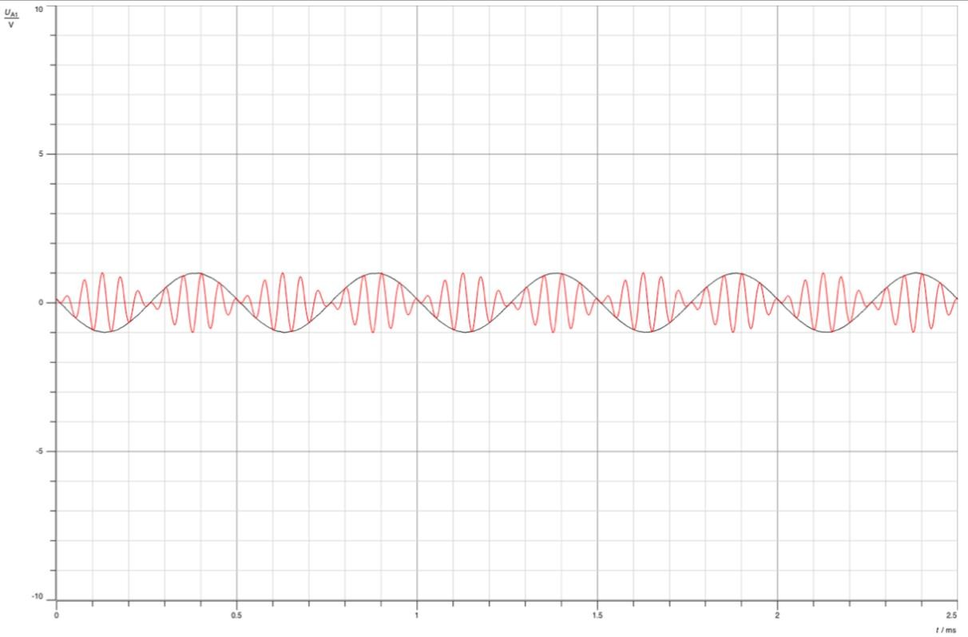

Figure 12: Modulated and message signal at Vss=2v (Time.domain)

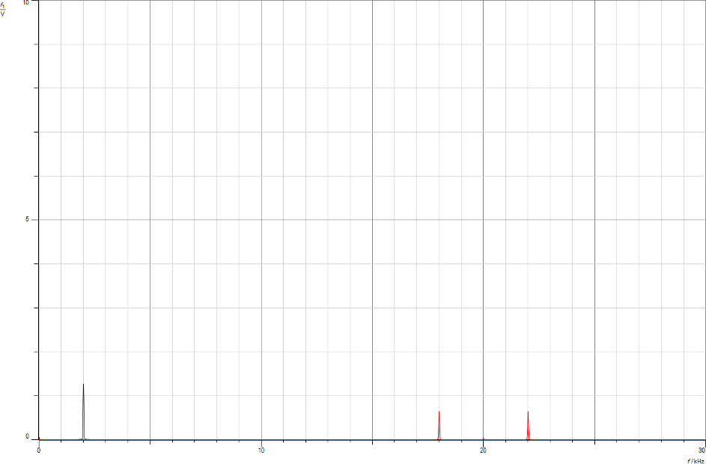

Figure 13: Modulated and message signal at Vss=2v(Freq.Domain)

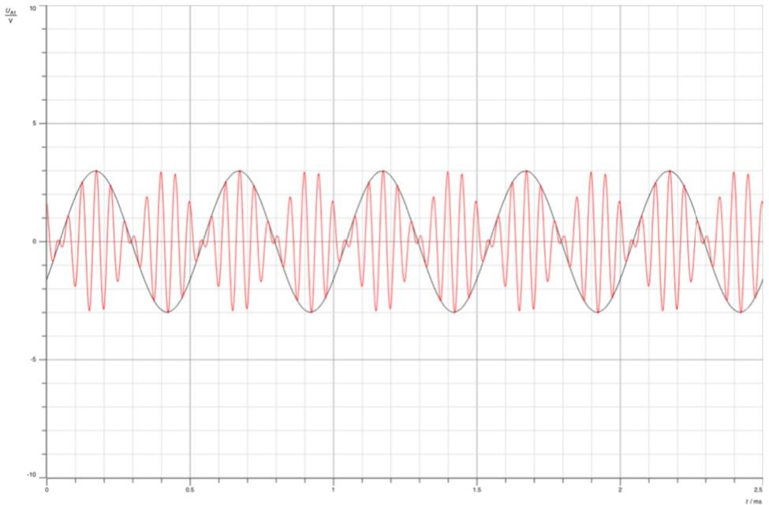

Figure 14: Modulated and message signal at Vss=6v (Time.domain)

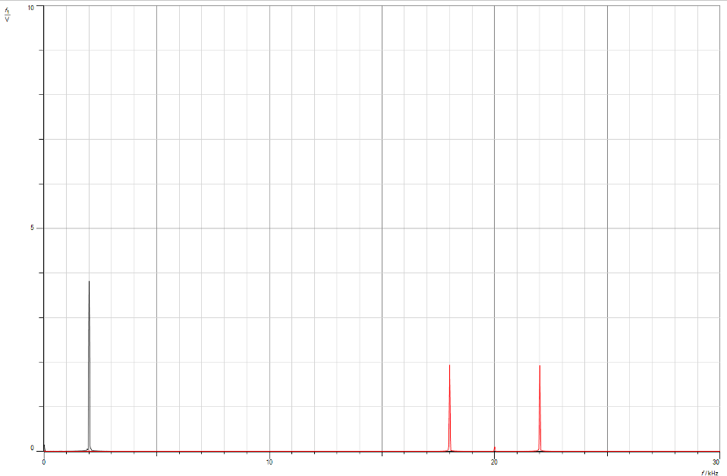

Figure 15: Modulated and message signal at Vss=6v (Freq.Domain)

From the above figures, we can observe that altering the amplitude of the modulating signal has a direct impact on the amplitude of the modulated signal, as depicted in the time domain figures. When the message signal amplitude (Vss) is set to 2, the amplitude of the modulated signal is measured as 1. Similarly, when Vss is adjusted to 6, the amplitude of the modulated signal increases to 3. This outcome aligns with our expectations, as the modulated signal (s(t)) is determined as s(t)= m(t)*c(t)).

Next, we proceeded to restore the function generator settings to its previous state: sine waveform, VSS set to 4V, and fm set to 2kHz. Additionally, we reverted the carrier signal back to its sinusoidal form. We then directly fed the message signal, m(t), into the modulator after passing it through a low pass filter. Upon examining the figure provided below, we noticed that when utilizing a filter for the message signal, the resulting modulated signal appeared to be out of phase with the message signal.

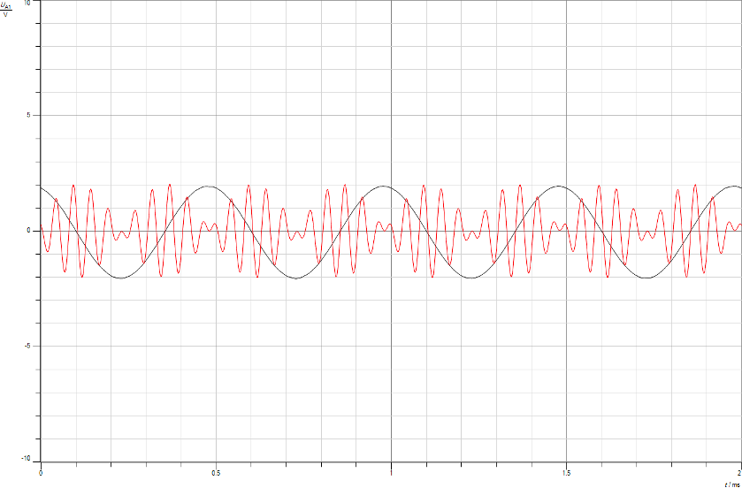

Figure 16: Modulated and message signal at Vss=4v (with-LPF)

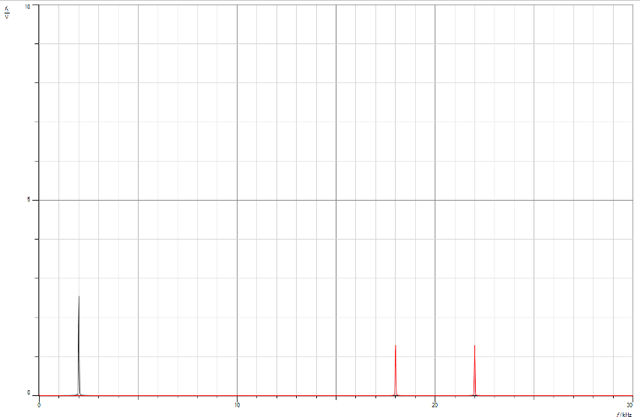

Figure 17: Modulated and message signal at Vss=4v (with-LPF)

Now we repeated the previous steps with a slight modification. This time we will use a sine waveform for the message signal (m(t)), with VSS set to 4V and fm set to 3kHz. It's important to note that in this case, we won't be using a low pass filter for the message signal. Upon examining the figures provided below, we can observe that without the filter, the message

signal and the modulated signal are in phase. This observation leads us to the realization that the purpose of filtering the message signal is primarily to eliminate any unwanted noise or interference that may be present in the message signal. However, it has little effect on the modulated signal itself. The main difference that we can observe is the phase difference between the message and modulated signals.

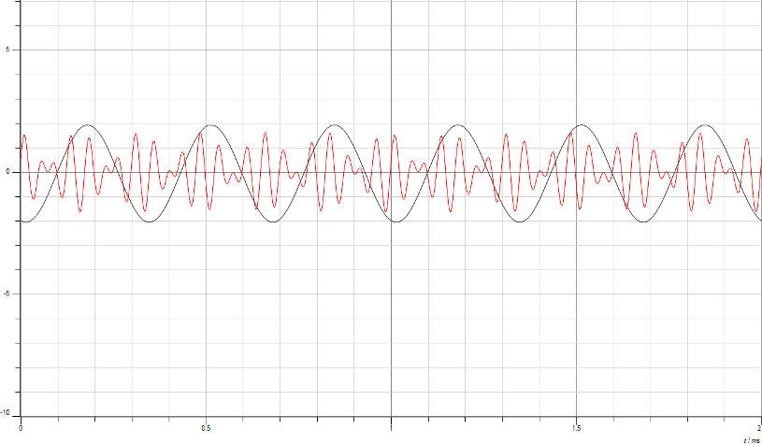

Figure 18: Modulated and message signal at fm=3khz (without-LPF)

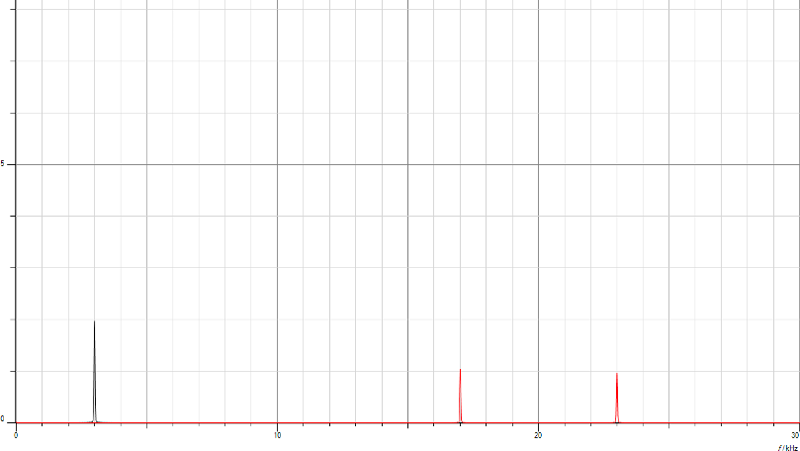

Figure 19: Modulated and message signal at fm=3khz (without.LPF in Freq.Domain)

### Double-side band suppressed carrier Demodulation:

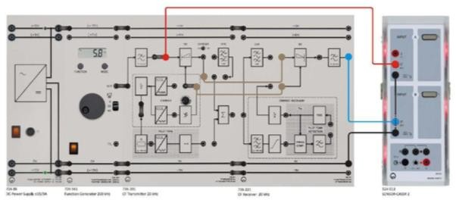

Figure 20: Demodulation setup [5]

To initiate the DSB-SC demodulation process, we began by assembling the components and connecting the wires according to the figure provided. In order to perform coherent demodulation, we set VSS to 4V and fm to 2kHz. Additionally, we adjusted the phase controller (φ) to the leftmost position, which corresponds to a minimum value of 0°.

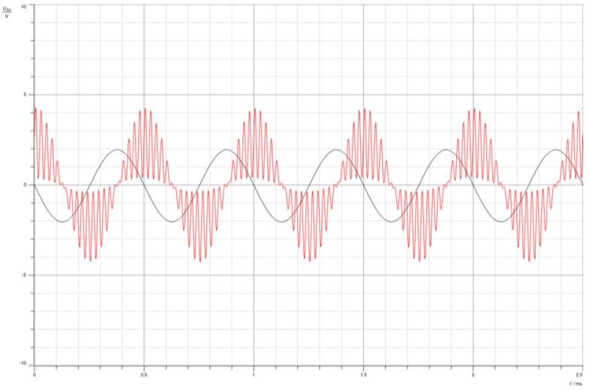

Figure 21: Demodulation without (output filter)

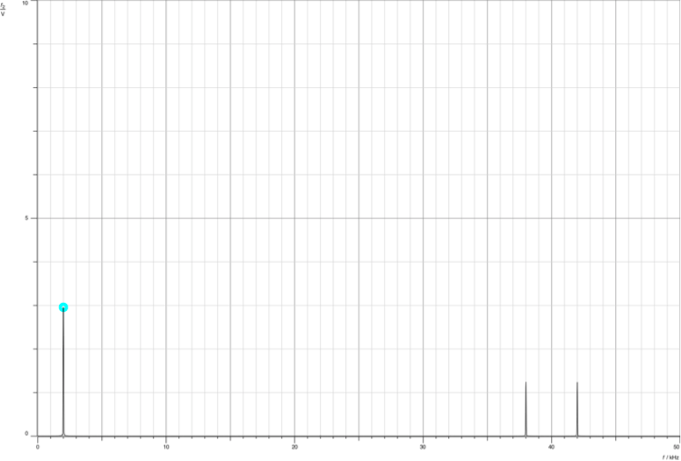

Figure 22: Demodulation (without output filter)

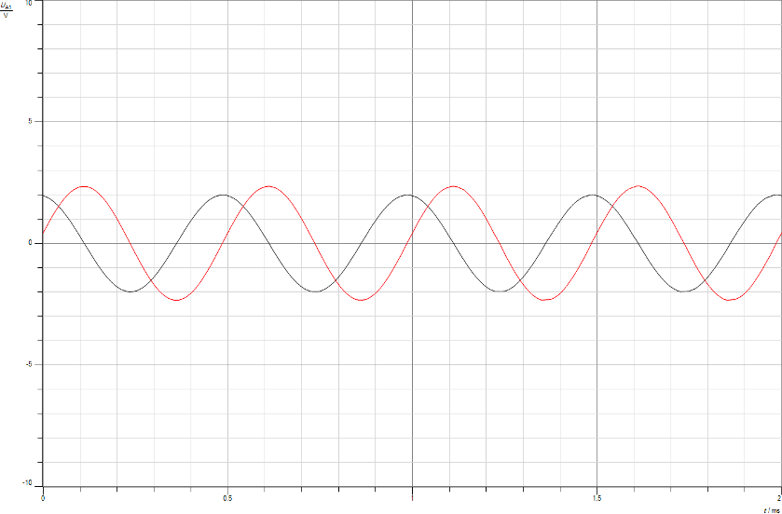

Figure 23: Demodulation (with output filter)

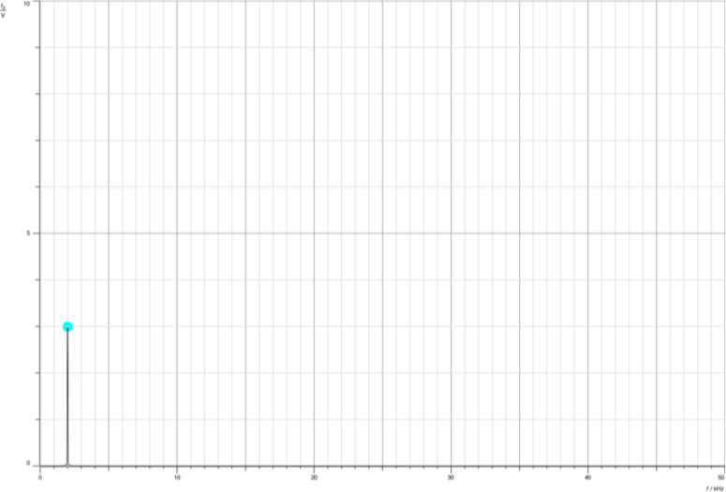

Figure 24: Demodulation (with output filter in Freq.Domain)

In the demodulation process, it is crucial to incorporate a low pass filter to extract only the desired message signal. Without the presence of a low pass filter, the demodulated signal would contain not only the message signal but also the unwanted sidebands generated by the DSB-SC modulation. By employing a low pass filter with a bandwidth slightly greater than the frequency of the modulating signal, we can effectively filter out the undesired components and obtain the clean message signal.

In order to explore the impact of non-coherence, we will introduce a change in the phase of the carrier signal using a phase-shifter (φ). When the phase is adjusted to 90 degrees, the output message signal will vanish. This is due to the nature of non-coherent demodulation, where the signal passes through a low pass filter resulting in the expression v(t) = (( Ac*Ac' ) / 2 )* cos(ϕ.m(t)). Since cos(90) equals 0, the message signal disappears entirely, as depicted in the figure provided below.

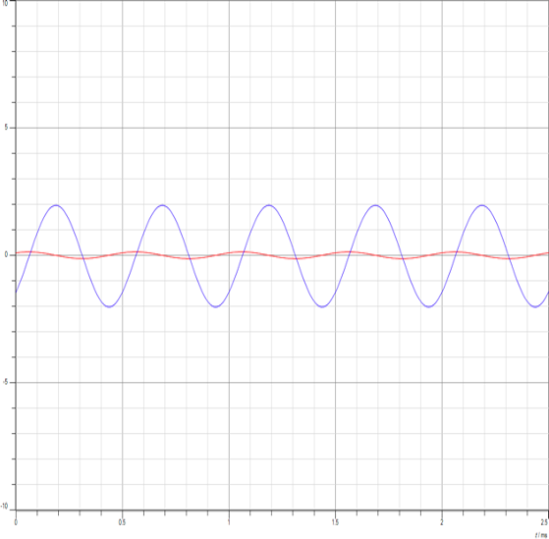

Figure 25: output message signal disappears

## Single-sideband Suppressed carrier Modulation

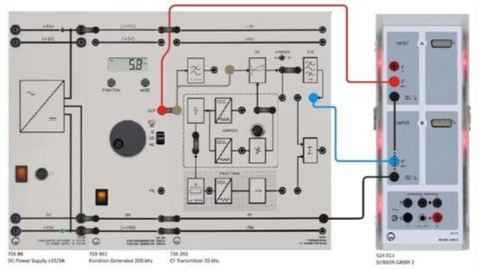

Figure 26: SSB-SC Modulation setup [5]

To begin the SSB-SC modulation process, we assembled the components and connected the wires according to the figure provided. We set the function generator to produce a sine waveform, with VSS set to 4V and fm set to 2kHz. In the case of SSB-SC modulation, we turned off the carrier toggle because we need to generate DSB-SC (double-sideband suppressed carrier) modulation first in order to obtain SSB-SC. The modulated signal, s(t), is obtained by S(t) =

m(t) *c(t), while selecting either the upper or lower side. Therefore, there is no need for an additional carrier signal in this case.

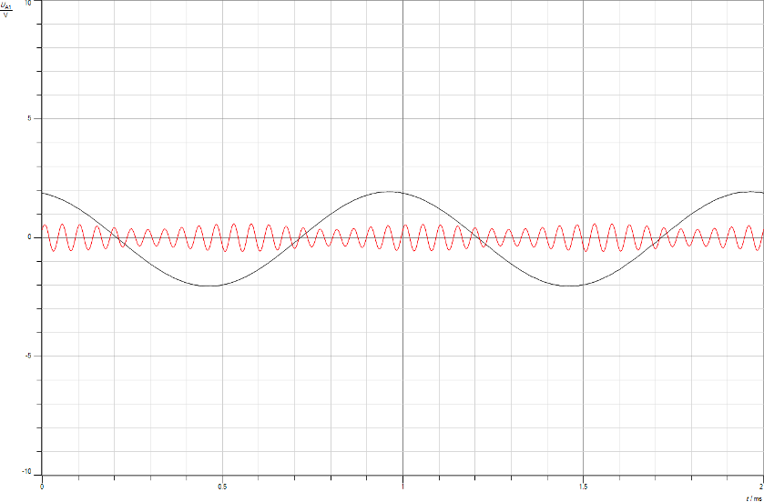

Figure 27: SSB-SC modulation

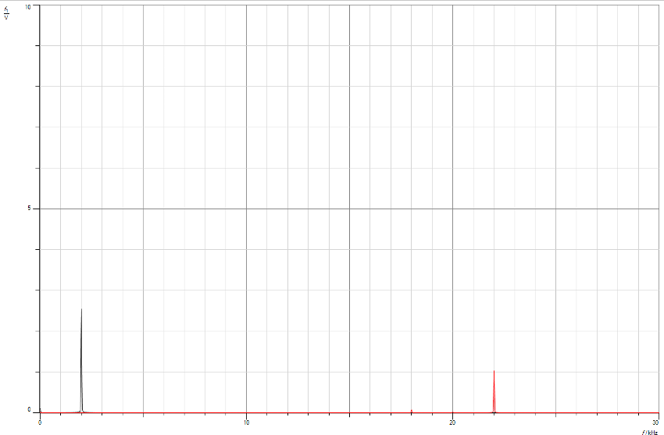

Figure 28: SSB-SC modulation(Freq.Domain)

As we notice in the figure above, it is evident that the upper sideband was generated at a frequency of (fc + fm = 20kHz + 2kHz = 22kHz), whereas the lower sideband did not transmit. The modulated signal follows a general formula of s(t) = ((Am * Ac) / 2) * cos[ 2π(fc + fm)t ] for the upper sideband, which can be simplified to s(t) = (Ac) * cos[ 2π.(22kHz).t] when using the given values.

Now, let's examine the effect of varying the frequency (fm) while keeping Vss at 4V. We will change the message frequency to 1kHz and 3kHz, respectively.

When fm is set to 1kHz, the upper sideband will occur at a frequency of (fc + fm = 20kHz + 1kHz = 21kHz). The lower sideband will still not transmit.

When fm is adjusted to 3kHz, the upper sideband will occur at a frequency of (fc + fm = 20kHz + 3kHz = 23kHz). Again, the lower sideband will not be present.

It's important to note that the frequencies of the sidebands are determined by the sum or difference of the carrier frequency (fc) and the message frequency (fm).



Figure 29: SSB-SC modulation Fm= 1khz

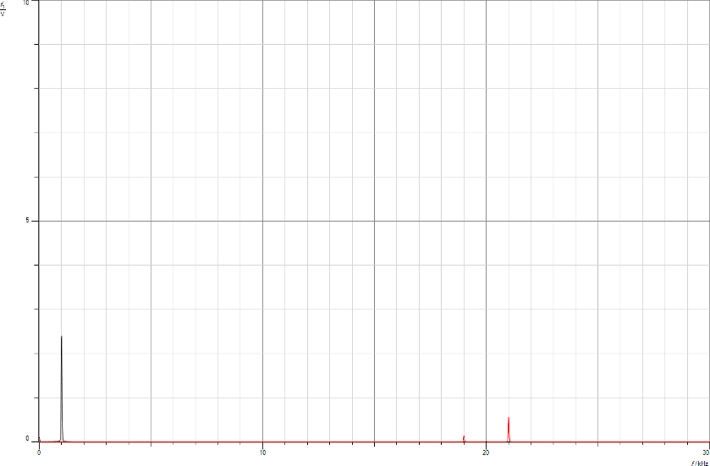

Figure 30: SSB-SC modulation Fm= 1khz(Freq.Domian)

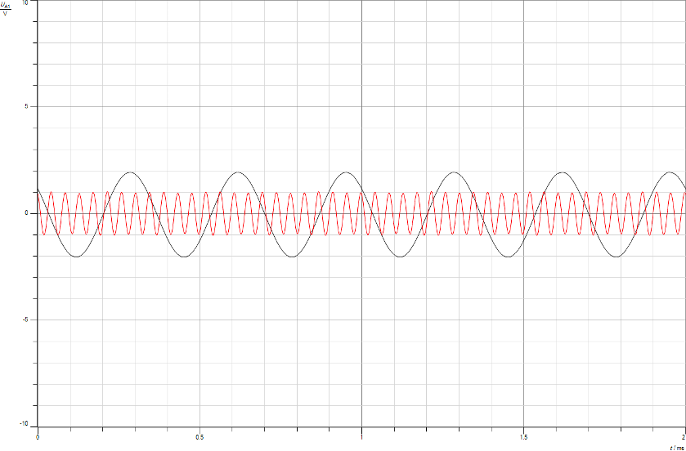

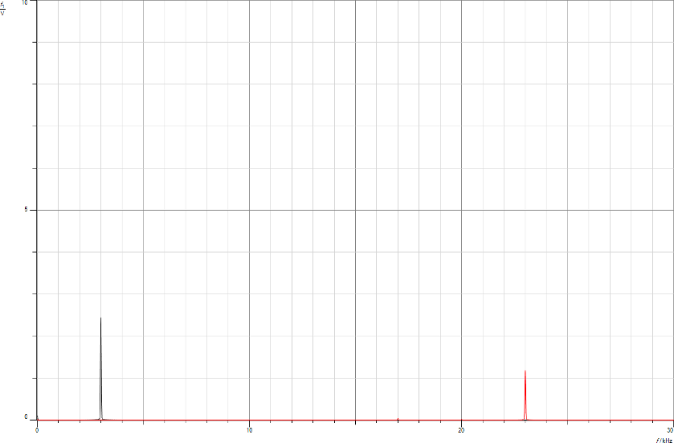Figure 31: SSB-S modulation Fm= 3khz (Time.domain)

Figure 32: SSB-SC modulation Fm= 3khz(Freq.Domian)

From From the provided figures, we can observe that altering the frequency of the modulating signal leads to a corresponding change in the frequency of the modulated signal, specifically the upper sideband. When the modulating frequency (fm) is set to 1kHz, the upper sideband occurs at a frequency of 21kHz. Similarly, when fm is adjusted to 3kHz, the upper sideband appears at a frequency of 23kHz.

In SSB-SC modulation, the transmission bandwidth is equal to the frequency of the modulating signal, as BW = fm. Therefore, in the first case with fm = 1kHz, the bandwidth is equal to 1kHz. In the second case with fm = 3kHz, the bandwidth increases to 3kHz.

Furthermore, the efficiency observed in SSB-SC modulation is 100%, as the power at the upper sideband (Pside) is equal to the total power (Ptotal). This can be expressed as

Pside / Ptotal = P(upper sideband) / P(upper sideband).

Next, you'll observe how adjusting the message signal's Amplitude affects things. You'll keep fm at 2 kHz and change the message Vss to 2V and 6V to see how this variation impacts the modulation..

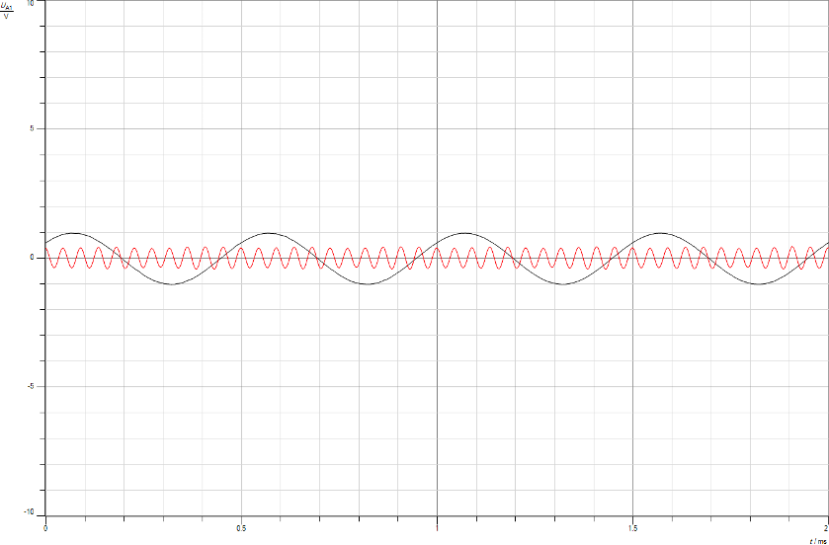

Figure 33: SSB-SC modulation Vss to 2V(Time.domain)

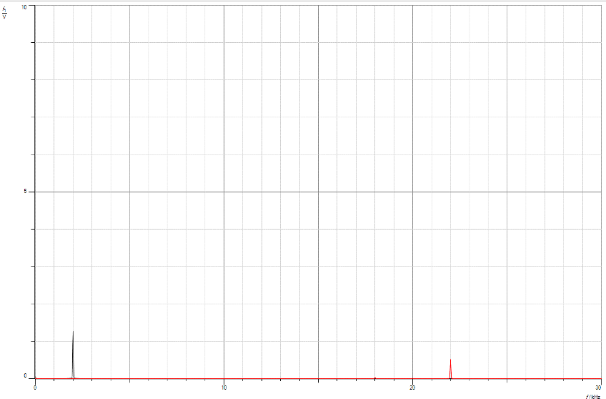

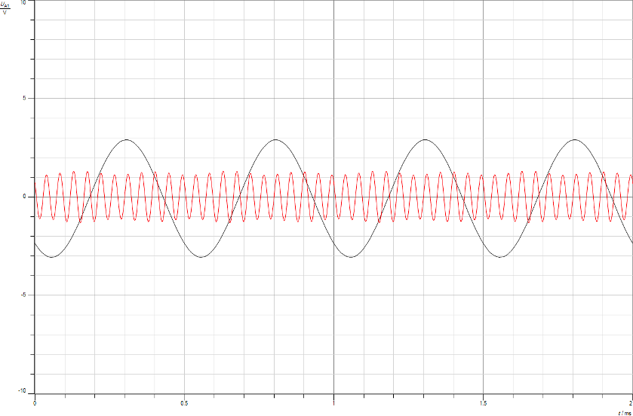Figure 34: SSB-SC modulation Vss to 2V(Freq.Domian)

Figure 35: SSB-SC modulation Vss to 6V(Time.domain)

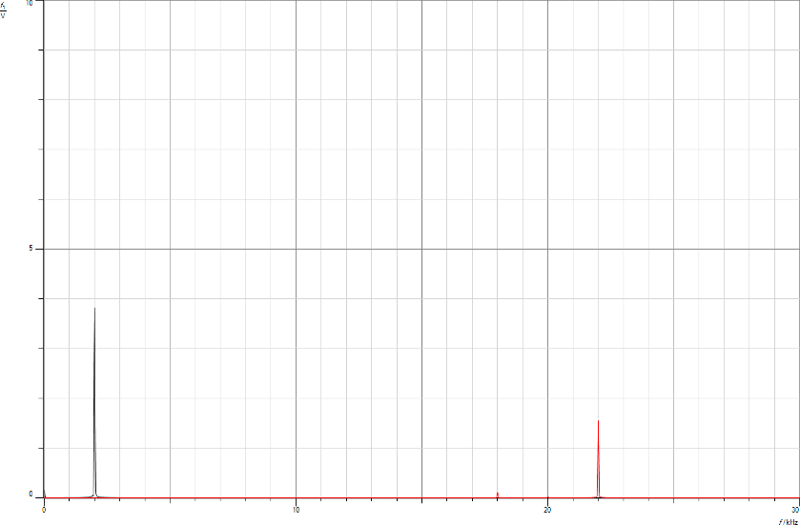

Figure 36: SSB-SC modulation Vss to 6V(Freq.Domian)

Looking at the earlier figures, it's clear that altering the modulating signal's amplitude directly affects the modulated signal's Amplitude, as shown in the time domain figures. For instance, with Vss at 2, the modulated signal's Amplitude is 1, while at Vss = 6, the Amplitude of the modulated signal increases to 3.

## Single-sideband Suppressed carrier Demodulation

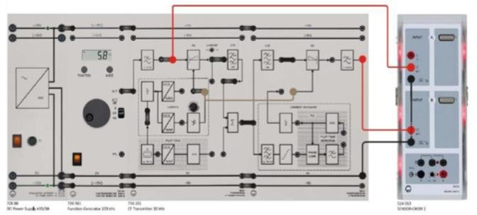

Figure 37: SSB-SC Coherent Demodulation Setup [5]

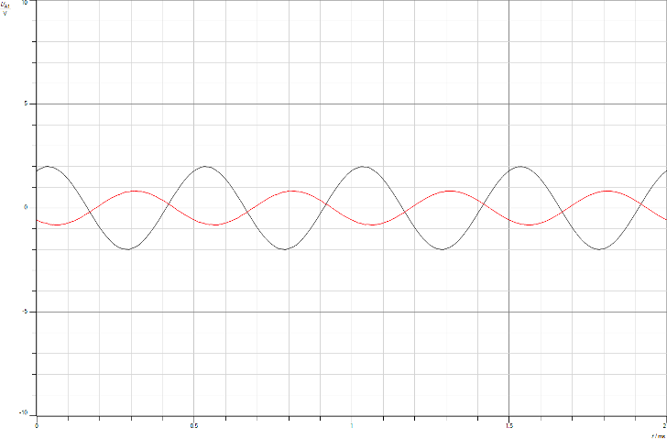First we began by putting together the components and wiring them as displayed in the figure for SSB-SC coherent demodulation. To kick things off, you configured the function generator to produce a sine wave, with VSS set at 4V and fm at 2 kHz. As you were working on coherent demodulation, you adjusted the phase-controller (φ) to its minimum value of 0°, positioned to the left.

Figure 38: SSB-SC Coherent Demodulation with output filter(Time.domain)

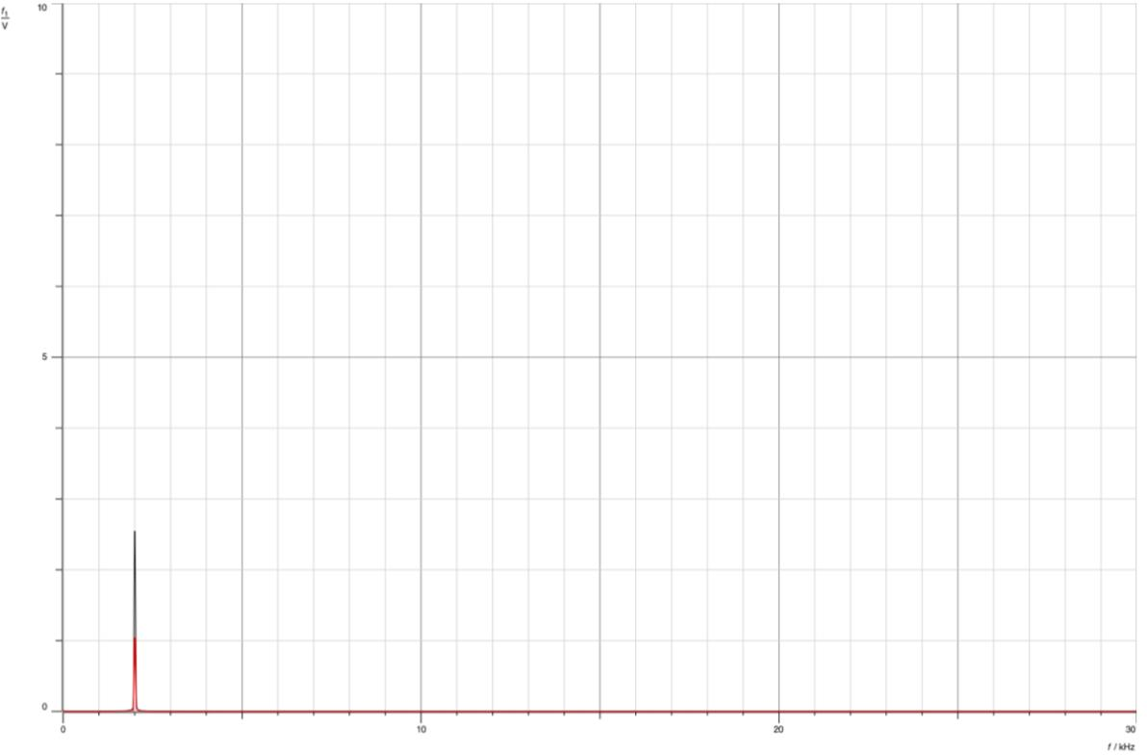

Figure 39: SSB-SC Coherent Demodulation with output filter (Freq.Domain)

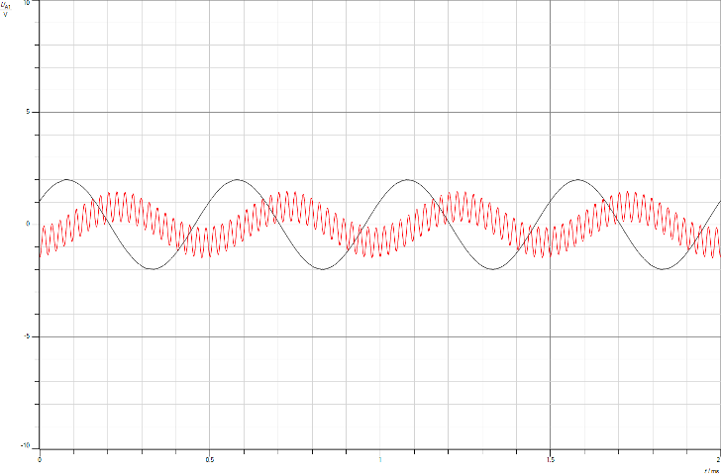

Figure 40: SSB-SC Coherent Demodulation without output filter(Time.domain)

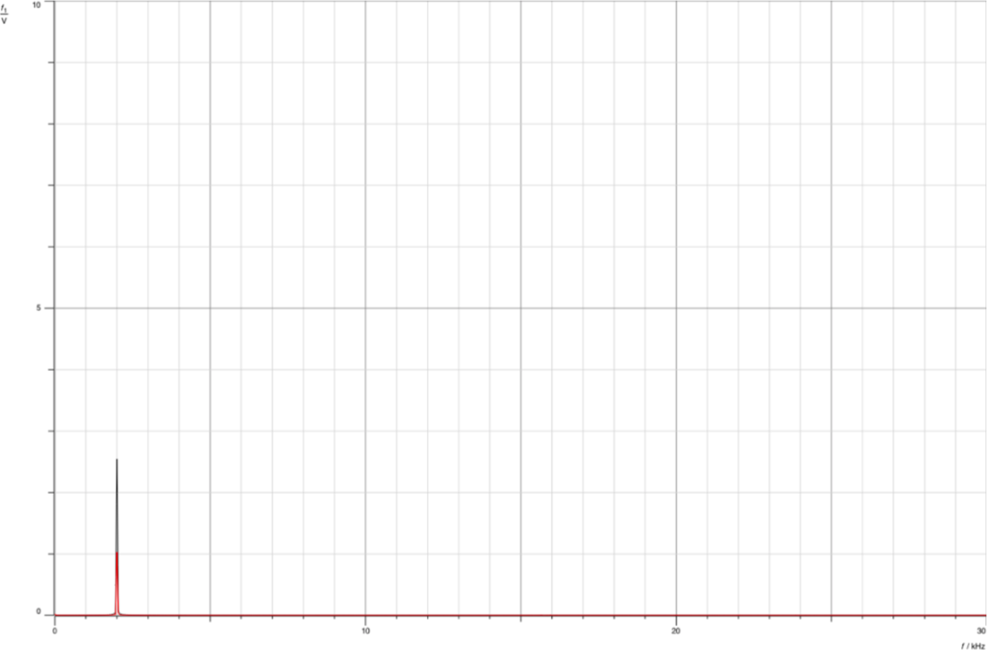

Figure 41: SSB-SC Coherent Demodulation without output filter(Freq.Domain)

To ensure the demodulation process captures only the message signal and eliminates any unwanted signals or noise from the surroundings, an output filter is necessary. In coherent demodulation, filters play a crucial role due to potential distortion when multiplying the modulated signal with a carrier. These filters help in refining the signal by addressing shifts or slight changes in amplitude that may occur during the process.

Non-coherent demodulation alters the carrier's phase through a phase-shifter (φ). At a phase angle of 90 degrees, the output signal vanishes, similar to the occurrence in DSB-SC with non-coherent demodulation, due to the cosine of 90 degrees equalling 0.

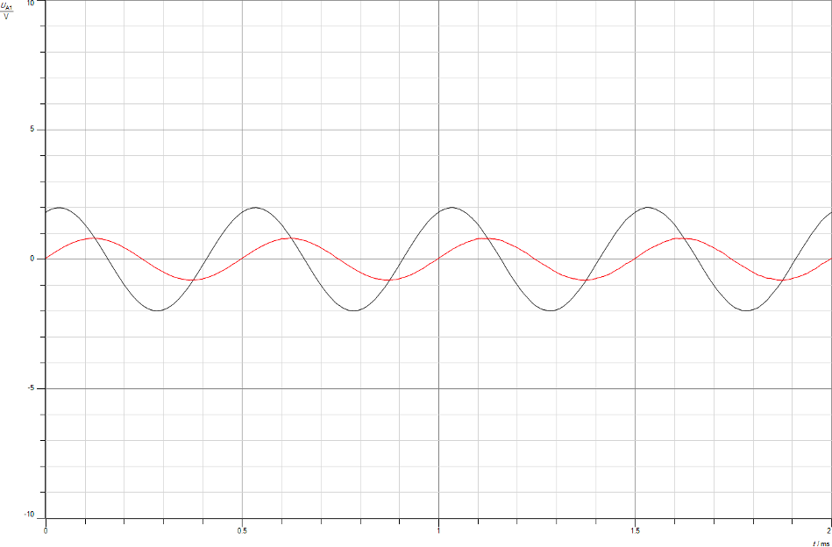

Figure 42: SSB-SC Non-Coherent Demodulation(Time.domain)

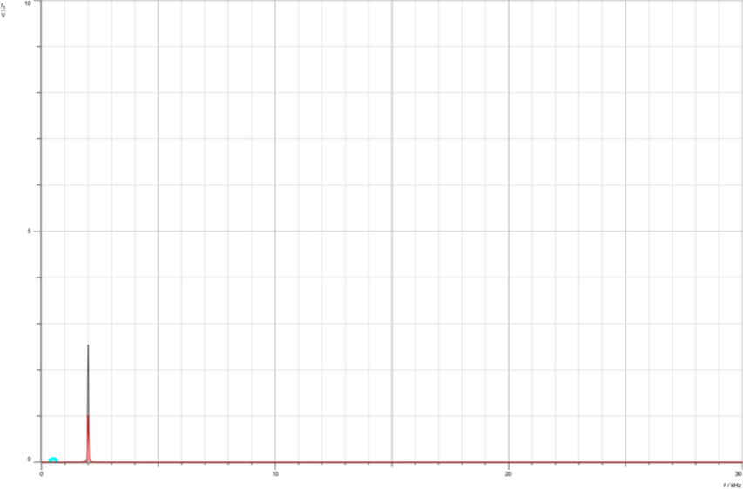

Figure 43: SSB-SC Non-Coherent Demodulation(Freq.Domain)

The next demodulation technique we're exploring is PL (Phase Locked Loop). This method takes in a reduced version of the carrier and reconstructs a complete carrier signal for the demodulation process. The setup, as depicted in the figure below, requires specific settings on the function generator: sine waveform, VSS set at 4V, and a frequency of 2kHz.

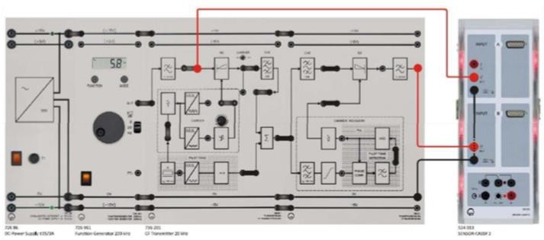

Figure 44: PPL demodulation setup [5]

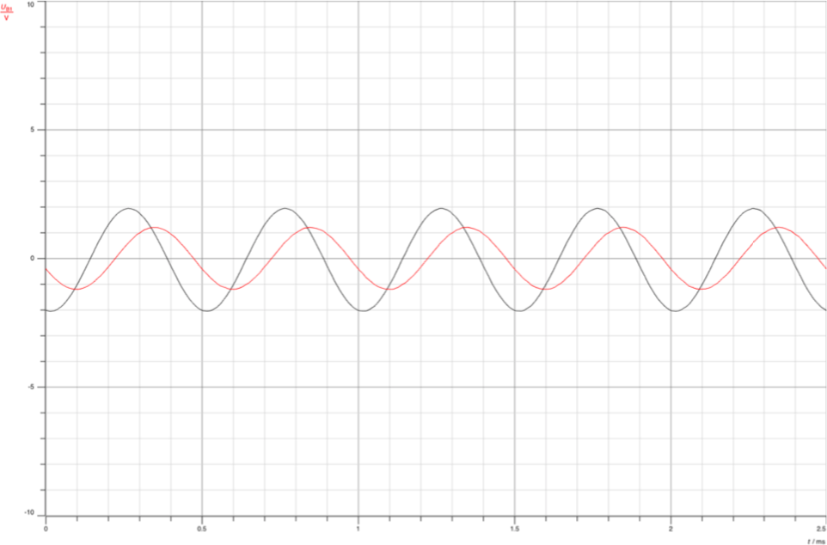

Figure 45: PPL demodulation(Time.domain)

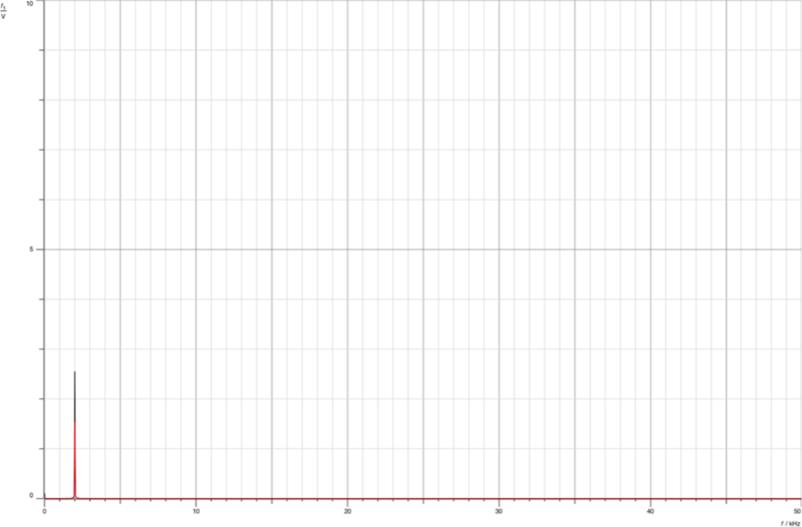

Figure 46: PPL demodulation (Freq.Domain)

In this observation, we've successfully recovered the message signal with the same frequency through PLL. However, there's a slight difference in amplitude. This occurs because the message signal retrieval might not be entirely precise due to the influence of filters, which can subtly affect the outcome.

## Conclusion

In this lab, the amplitude modulations of double sideband suppressed carrier (DSB) and single sideband suppressed carrier (SSB) were covered. The modulation and demodulation processes in both the time and frequency domains were discussed. Specifically how the SSB- SC is generated from DSB-SC. There are many demodulation methods discussed in this lab to retrieve the message signal such as (coherent detection) demodulation, non-coherent demodulation, and phase locked loop demodulation. Moreover, the importance of-filters and why we use them was discussed, as well as how changes in the frequency and amplitude of the message signal affect modulated signals.

# References

1. :[www.rajalakshmi.org/VLabsRECUpdated/theory.html#:~:text=The%20DSB%2DSC%20mo](http://www.rajalakshmi.org/VLabsRECUpdated/theory.html#%3A~%3Atext%3DThe%20DSB%2DSC%20modulated%20signal%20is%20henceforth%20multiplied%20with%20the%2Cmessage%20signal) [dulated%20signal%20is%20henceforth%20multiplied%20with%20the,message%20signal](http://www.rajalakshmi.org/VLabsRECUpdated/theory.html#%3A~%3Atext%3DThe%20DSB%2DSC%20modulated%20signal%20is%20henceforth%20multiplied%20with%20the%2Cmessage%20signal) [Accessed 28 Nov. 2023, 13:32]
2. :<https://electronicscoach.com/double-sideband-suppressed-carrier-modulation.html> [Accessed 28 Nov. 2023, 13:49]
3. :[https://www.tutorialspoint.com/analog_communication/analog_communication_dsbsc_demo](https://www.tutorialspoint.com/analog_communication/analog_communication_dsbsc_demodulators.htm) [dulators.htm](https://www.tutorialspoint.com/analog_communication/analog_communication_dsbsc_demodulators.htm) [Accessed 28 Nov. 2023, 14:40]
4. :[https://www.tutorialspoint.com/analog_communication/analog_communication_ssbsc_demo](https://www.tutorialspoint.com/analog_communication/analog_communication_ssbsc_demodulator.htm) [dulator.htm](https://www.tutorialspoint.com/analog_communication/analog_communication_ssbsc_demodulator.htm) [Accessed 28 Nov. 2023, 14:56]
5. :Communication lab manual version 3 [Accessed 29 Nov. 2023, 22:12]